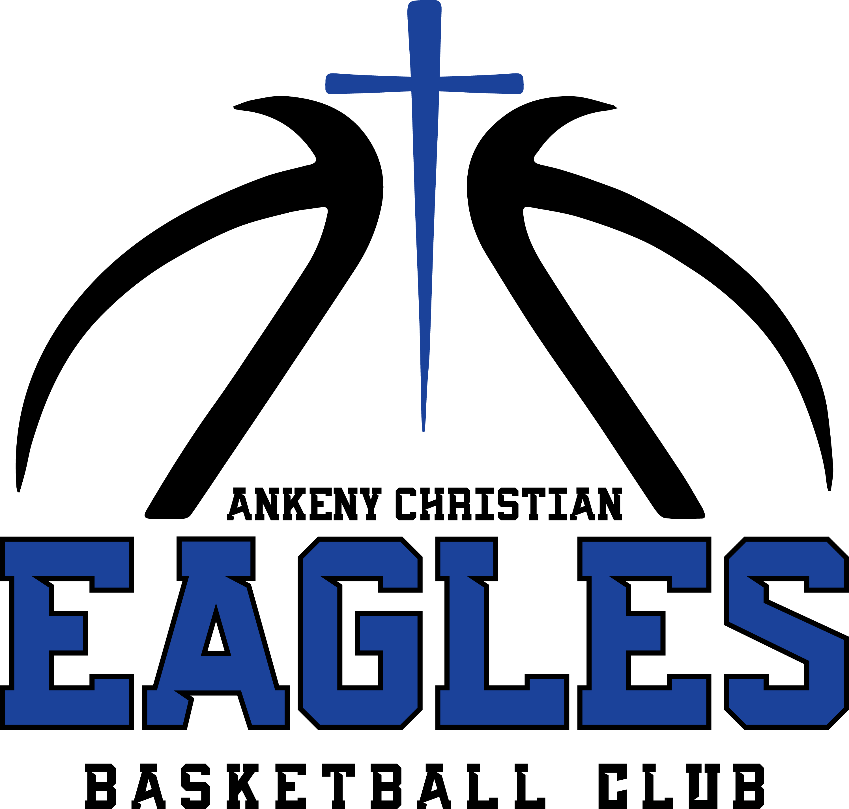 | LIGHT UP THE COURT CLASSIC  COACH & OFFICIAL QUICK RULES REFERENCE
October 31, 2026 | Ankeny, Iowa | ACE Basketball Club
COACH & OFFICIAL QUICK RULES REFERENCE
DIV | BALL | BASKET | DEFENSE | ZONE / TRAP | FULL-COURT PRESS | PRESS CAP | FT LINE
3rd | 28.5" | 10 ft | M2M only | NO | Final 2:00 only - M2M | +15 | ~12 ft
4th | 28.5" | 10 ft | M2M only | NO | Final 2:00 only - M2M | +15 | Reg.*
5th | 28.5" | 10 ft | All legal | YES | Final 2:00 only - M2M | +15 | Reg.
6th | 28.5" | 10 ft | All legal | YES | All game | +20 | Reg.
7th | 28.5" | 10 ft | All legal | YES | All game | +20 | Reg.
*4th Grade FT: player may cross after release but may not pursue rebound because of the step-over.
GAME FORMAT  • 2 x 18-minute halves; 2-minute halftime  • Running clock  • Final 1:00: normal stop clock if margin <=10  • 2 x 30-sec timeouts/team; +1 in OT  • 5 fouls = disqualification  • 7th team foul/half = 2 FTs; no 1-and-1  • Team fouls reset at halftime | MERCY / OVERTIME  • 20+ lead in 2nd half = running clock  • Below 20 = normal clock rules resume  • 20+ lead with 2:00 or less = GAME OVER  • OT #1: 2 minutes  • OT #2: 1 minute  • Still tied: sudden death, first score wins  • Technical: 2 FTs + possession
Officials have final authority on judgment calls. Tournament director has final authority on tournament administration.

